Permit No.
Report No.

EARTH DISTURBANCE INSPECTION REPORT
Project Name Inspection Date Inspection Time
Weather Conditions Total Project Area
Location Total Disturbed Area
Municipality County
Receiving Water(s) Designated/Existing Use
Responsible Party(s)
(name & address)

Phone ( ) ( )
Site Representative (name) Inspector (name)
(title) (title)
Type of Inspection (check only one) |  |  |  |  |  | Photographs Taken Yes No
Routine complete Routine partial Follow-up Complaint Final
Site Description & Observations:

Continued on page 4.
Permit and Plan Requirements |  |  |  | Type of Activity (check as many as appropriate)
Y | N |  |  |  |  |  |  | Other
 |  | Written Erosion & Sediment Plan required |  |  | Pub. Road Constr./Maint. (PRC) |  |  | Pvt. Road/Residence (PRRS)
 |  | Written Post Construction Stormwater Management Plan required |  |  | Res. Subdivision (RSBD) |  |  | Comm./Indust. Dev. (CMIN)
 |  | Erosion & Sediment Plan requested |  |  | Govmt. Facilities (GOV) |  |  | Recreation Facilities (RECF)
 |  | Post Construction Stormwater Management Plan requested |  |  | Utilities Facilities (UTL) |  |  | Agricul. Activities (AGA)
 |  | E & S Permit required ESCGP Permit required |  |  | Sewer/Water Systems (SWS) |  |  | Pipeline (PL)
 |  | NPDES Permit required |  |  | Remediation/Restoration (RRES) |  |  | Silviculture (SILV)
 |  | Phased Constr. | Non-Phased Constr.
Permit #: Exp. Date:

Page 1 of 4
White - Inspector Yellow - Responsible Party Pink - Department Goldenrod - Other
3150-FM-BWEW0092 Rev. 10/2015

This report is official notification that a representative of the Department of Environmental Protection has conducted an inspection of your earth disturbance activity to determine compliance with Title 25, Chapter 92a, National Pollutant Discharge Elimination System, Title 25, Chapter 102, Erosion and Sediment Control, and the Pennsylvania Clean Streams Law. This representative may be an employee of the local County Conservation District, which by delegation agreement with the Department of Environmental Protection, is authorized to investigate complaints, inspect earth disturbance activities and conduct compliance actions. Any violations observed by the Department/Conservation District have been noted on this report form and constitute unlawful conduct as defined in Section 611 of the Clean Streams Law.
There will be no written confirmation of those violations from the Department. Failure to take corrective actions to resolve the violations may result in administrative, civil and/or criminal penalties being instituted by the Department of Environmental Protection as defined in Section 602 of the Clean Streams Law of Pennsylvania. The Clean Streams Law provides for up to $10,000 per day in civil penalties, up to $10,000 in summary criminal penalties, and up to $25,000 in misdemeanor criminal penalties for each violation.
This report does not constitute an Order or appealable action of the Department. Nothing contained herein shall be deemed to grant or imply immunity from legal action for any violation noted herein.
For further information or assistance please contact:

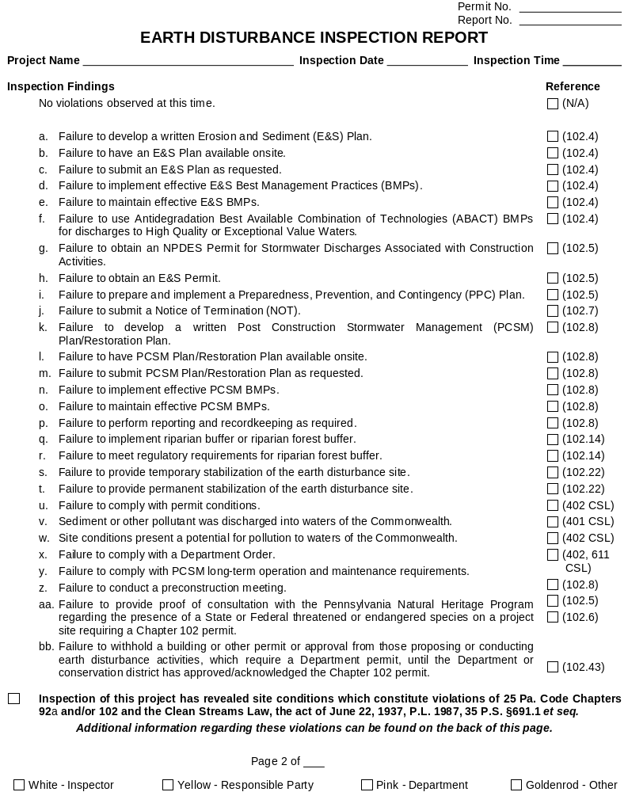

Permit No.
Report No.

EARTH DISTURBANCE INSPECTION REPORT
Project Name Inspection Date Inspection Time

Continuation Sheet
Site Description & Observations
Compliance Assistance Measures
Follow-up Inspection will occur on or about (date)
(Signature of Site Representative) (Date) |  |  |  |  | (Inspector’s Signature) (Date)

The Site Representatives' signature acknowledges that they have read the report and received a copy and that they were given an opportunity to discuss it with the inspector. The signature does not necessarily mean the signee agrees with the report.
Page 4 of 4
White - Inspector Yellow - Responsible Party Pink - Department Goldenrod - Other

